Amr Mohamed Mahmoud Ebrahim Fayad
Theoretical Questions
Mention the usage of interrupts and timers in ESP project and why it is important?
- Timer Interrupt Considerations

- These routines

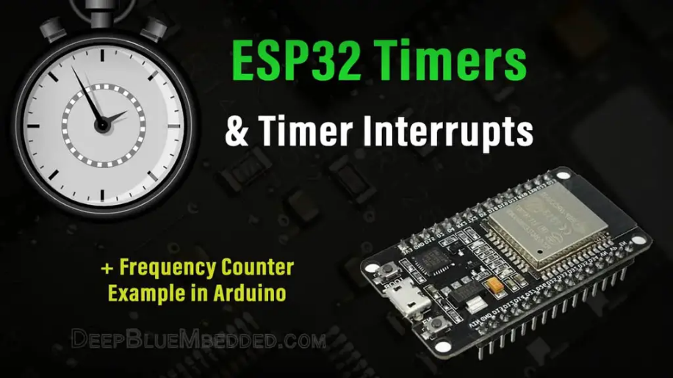
- need to be extremely fast to execute, and it is often best to simply set a number of flags or states within the Interrupt Service Routine, then evaluate them when required in your normal thread code in loop().
- only fire when the configured timer overflows
- are restricted to a small number of timers depending on the MCU hardware in use.
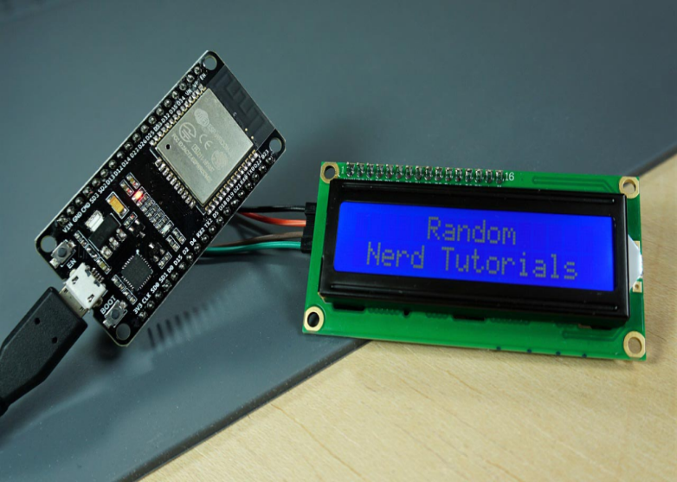
- can only set values to variables declared with VOLATILE, which ensures they arent optimized away, and can be used reliably in the ISR and in the main loop() code
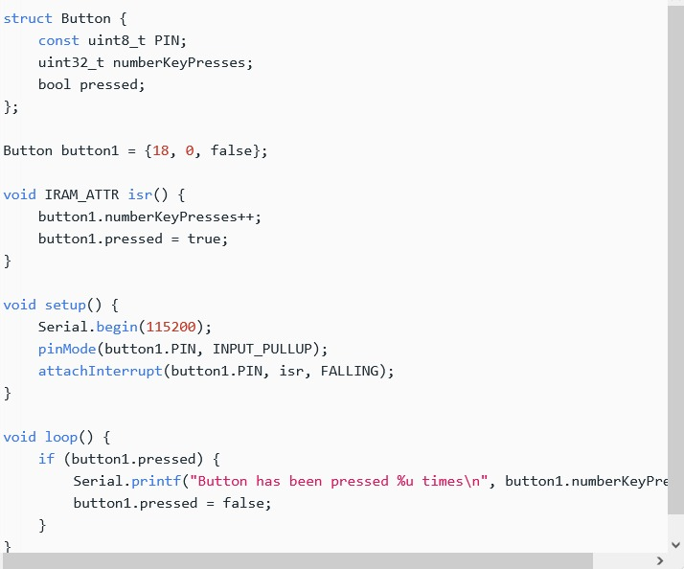
for example:
How does the ESP32 interface with an LCD display, and what are the common communication protocols used for this purpose?

Interfacing I2C LCD with ESP32
Serial communication sends data one bit at a time over a single data line, which requires fewer pins than parallel communication. This can be slower but is easier to manage with fewer pins.
LCDs: Serial LCDs like those using the HD44780 with an I2C or SPI interface.

- I2C (Inter-Integrated Circuit):
  - How it works: Uses two wires, SDA (data) and SCL (clock). An I2C interface LCD has a built-in I2C controller, simplifying connections and programming.
  - Libraries: For instance, Wire library for I2C communication and LiquidCrystal_I2C for the LCD.
- SPI (Serial Peripheral Interface):
  - How it works: Uses four wires: MOSI (Master Out Slave In), MISO (Master In Slave Out), SCK (Serial Clock), and CS (Chip Select). SPI is faster than I2C but uses more pins.
  - Libraries: Adafruit_ILI9341 or similar libraries for SPI-based LCDs.
Connecting an LCD to ESP32:
- Parallel LCD:
  - Pins Required: Multiple GPIO pins for data and control lines.
  - Connection: Data lines (D0-D7) connect to GPIOs, RS, E, and RW also connect to GPIOs.
  - Libraries: Libraries like LiquidCrystal (in Arduino IDE) are used to control these displays.
- I2C LCD:
  - Pins Required: Two GPIO pins (SDA and SCL).
  - Connection: Connect SDA to the ESP32’s SDA pin and SCL to the SCL pin. An I2C LCD module usually comes with an I2C backpack that simplifies connections.
  - Libraries: LiquidCrystal_I2C or Wire library for I2C communication.
- SPI LCD:
  - Pins Required: Four GPIO pins (MOSI, MISO, SCK, and CS), plus possibly additional pins depending on the LCD model.
  - Connection: Connect the MOSI, MISO, SCK, and CS pins to the corresponding ESP32 GPIOs.
  - Libraries: Libraries like Adafruit_ILI9341 for specific SPI LCDs.

How can an IR sensor be used to detect objects, and what is the principle behind its operation?
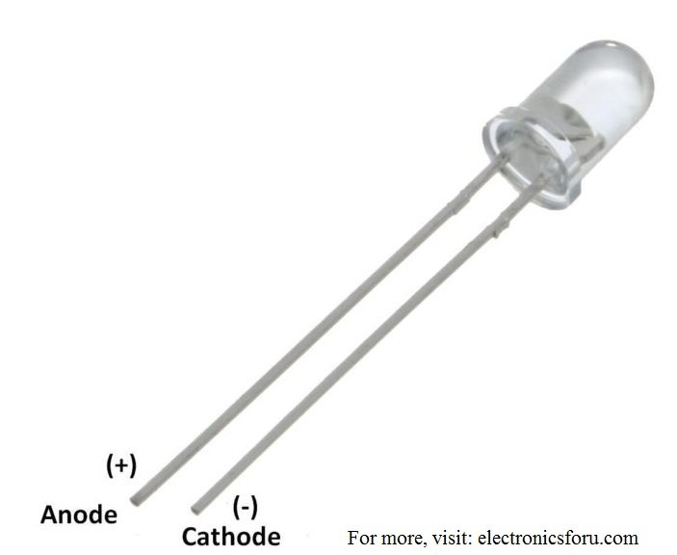
In this photo its example pf IR : An IR LED is a type of diode or simple semiconductor
An IR sensor is an electronic device that detects IR radiation falling on it. Proximity sensors (used in touchscreen phones and edge-avoiding robots), contrast sensors (used in line following robots), and obstruction counters/sensors (used for counting goods and in burglar alarms) are some applications involving IR sensors.

- IR Sensor Working Principle
An IR sensor consists of two parts, the emitter circuit, and the receiver circuit. This is collectively known as a photo-coupler or an optocoupler.
The emitter is an IR LED and the detector is an IR photodiode. The IR photodiode is sensitive to the IR light emitted by an IR LED. The photodiode’s resistance and output voltage change in proportion to the IR light received. This is the underlying working principle of the IR sensor.
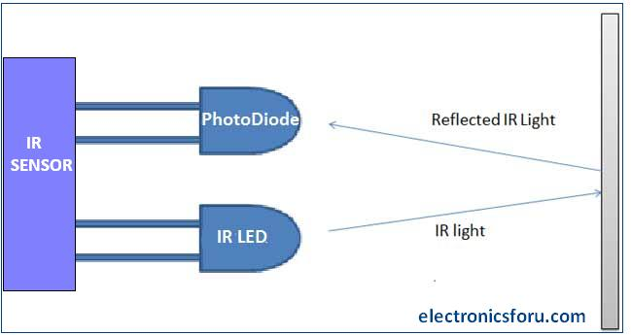
The type of incidence can be direct incidence or indirect incidence. In direct incidence, the IR LED is placed in front of a photodiode with no obstacle.
In indirect incidence, both the diodes are placed side by side with an opaque object in front of the sensor. The light from the IR LED hits the opaque surface and reflects back to the photodiode.
How can PWM signals be generated using the ESP32, and what are the main factors to consider when configuring PWM?
- Pulse Width Modulation (PWM) is a technique by which the width of a pulse is varied while keeping the frequency of the wave constant. It is a method for generating an analog signal using a digital source.

PWM Pins of ESP32
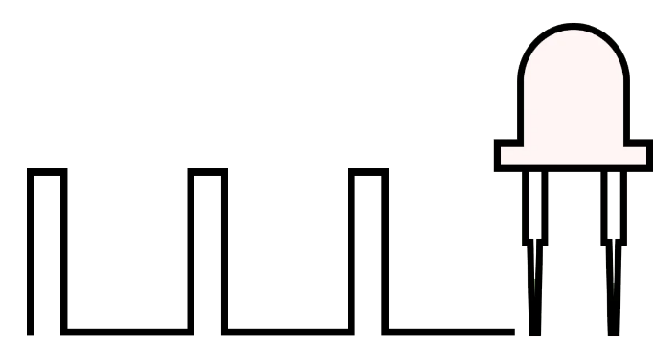
ESP32 Wroom module has 28, 0 to 16-bit PWM channels. Pins with the symbol ‘~’ represent that it has PWM support. These PWM pins are shown below image

- Control LED Brightness using
Let’s build an application in which we will control the brightness of LED using ESP32 by varying the potentiometer knob. So, when we rotate the knob of the potentiometer, the ADC of ESP32 will read this analog signal. Then we will generate PWM signal proportional to the analog signal.

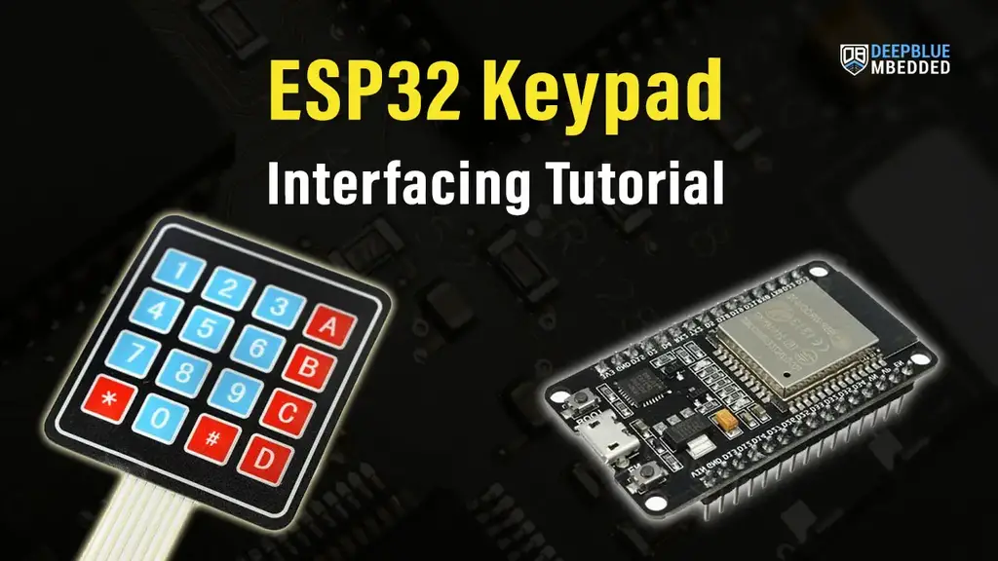
Discuss the principle behind matrix keypads and how they can be interfaced with the ESP32 for user input:
- Keypad is used as an input device to read the key pressed by the user and to process it.
- 4x4 keypad consists of 4 rows and 4 columns. Switches are placed between the rows and columns.
- A key press establishes a connection between the corresponding row and column, between which the switch is placed.
- For more information about the keypad and how to use it, refer to the topic 4x4 Keypad in the sensors and modules section.
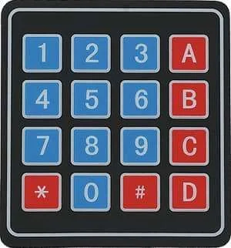

Keypad 4×4 Example
